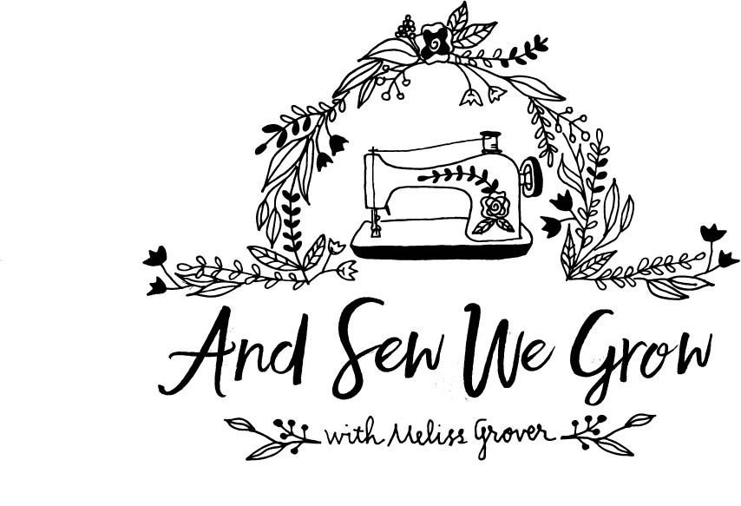

Waiver Form
I acknowledge __________________________ (student’s name) for the following:
I agree to release and hold harmless Meliss Grover, all employees and/or volunteers of And Sew We Grow all claims or liability related to any accident that may arise as a result of my and/or my child’s participation in this program.
I understand that sewing includes the use of machines, hot irons, needles, scissors, and other tools. These activities include risks that can cause or lead to injury. I grant permission to operate machines and to use tools and equipment. I give permission for first aid and/or medical treatment to be given if the need arises.
PHOTOGRAPHIC RELEASE
I grant And Sew We Grow, its representatives and employees, the right to take photographs of me and/or my child in connection with sewing classes. I authorize And Sew We Grow its assigns and transferees to copyright, use and publish without mention of my child’s name the same in print and/or electronically. I agree that And Sew We Grow may use such photographs of me/my child for any lawful purpose, including for example such purposes as publicity, illustration, advertising, and Web content. I have read and understand the above.

REFUNDS & WITHDRAWAL POLICY
- All refunds must be submitted in writing to And Sew We Grow requesting withdrawal and refund seven days prior to program starting.
- A $10.00 administrative fee will be held from the account. There are no refunds or credits for absences.

CLASS CANCELLATION POLICY
If classes or camps are cancelled, a make-up class or refund will be issued.

BEHAVIOR
And Sew We Grow reserves the right to withdraw a student from lessons for inappropriate behavior. Due to the nature of working with machinery and sharp objects, And Sew We Grow will not tolerate behavior deemed dangerous or harmful. And Sew We Grow reserves the right to terminate lessons and no refund will be issued.
And Sew We Grow reserves the right to invite a child to return to lessons if parent/child demonstrates improved behavior.

I have read the above waiver and agree to all of its terms.
Signature: ________________________________________

